登陆流程伪代码说明
Author：吕嘉伟 08386221
Version 0.1
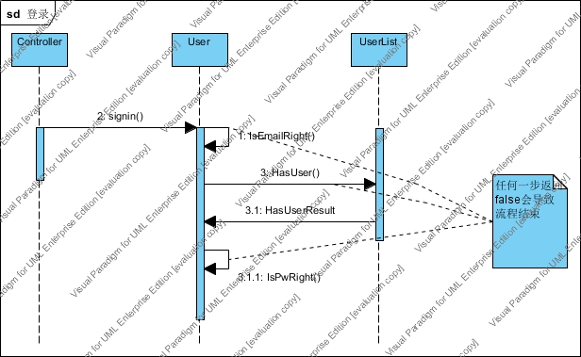
伪代码：
Signin（）;
If the e-mail isn't right;
Return false;
If the password isn't right;
Return false;
Return true;

